Virtual base class is used in situation where a derived have multiple copies of base class. Consider the following figure:

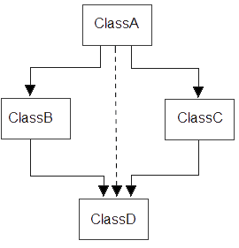

**Example without using virtual base class**

#include<iostream.h>

#include<conio.h>

class ClassA

{

public:

int a;

};

class ClassB : public ClassA

{

public:

int b;

};

class ClassC : public ClassA

{

public:

int c;

};

class ClassD : public ClassB, public ClassC

{

public:

int d;

};

void main()

{

Class D obj;

obj.a = 10; **//Statement 1, Error occur**

obj.a = 100; **//Statement 2, Error occur**

obj.b = 20;

obj.c = 30;

obj.d = 40;

cout<< "\n A : "<< obj.a;

cout<< "\n B : "<< obj.b;

cout<< "\n C : "<< obj.c;

cout<< "\n D : "<< obj.d;

}

Output :

A from ClassB : 10

A from ClassC : 100

B : 20

C : 30

D : 40

In the above example, both **ClassB** & **ClassC** inherit **ClassA**, they both have single copy of **ClassA**. However **ClassD** inherit both **ClassB** & **ClassC**, therefore **ClassD** have two copies of **ClassA**, one from **ClassB** and another from **ClassC**.

Statement 1 and 2 in above example will generate error, bco'z compiler can't differentiate between two copies of **ClassA** in **ClassD**.

To remove multiple copies of **ClassA** from **ClassD**, we must inherit **ClassA** in **ClassB**and **ClassC** as **virtual** class.

**Example using virtual base class**

#include<iostream.h>

#include<conio.h>

class ClassA

{

public:

int a;

};

class ClassB : **virtual** public ClassA

{

public:

int b;

};

class ClassC : **virtual** public ClassA

{

public:

int c;

};

class ClassD : public ClassB, public ClassC

{

public:

int d;

};

void main()

{

ClassD obj;

obj.a = 10; **//Statement 1**

obj.a = 100; **//Statement 2**

obj.b = 20;

obj.c = 30;

obj.d = 40;

cout<< "\n A : "<< obj.a;

cout<< "\n B : "<< obj.b;

cout<< "\n C : "<< obj.c;

cout<< "\n D : "<< obj.d;

}

Output :

A : 100

B : 20

C : 30

D : 40

According to the above example, **ClassD** have only one copy of **ClassA** and statement 4 will overwrite the value of **a**, given in statement 3.